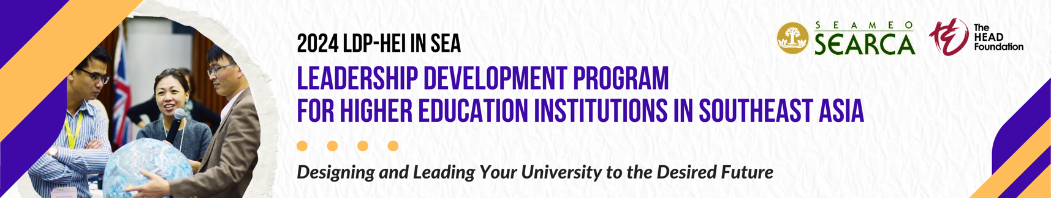

PERSONAL STATEMENTS
(By the Applicant/Nominee)
Please provide your statements in less than 250 words per question. This form should not go beyond one page. Once complete, append your signature, convert this document into a single PDF, and upload it to the application portal.
- Describe your current work responsibilities and the kind of activities, operations, and decisions you are directly responsible for.

- Please describe below the main reasons why you should be awarded the SEARCA grant to participate in the 2024 LDP-HEI program and how your participation could add value to you, your colleagues, and your University.

__________________________________________
Signature over the printed name of the applicant

