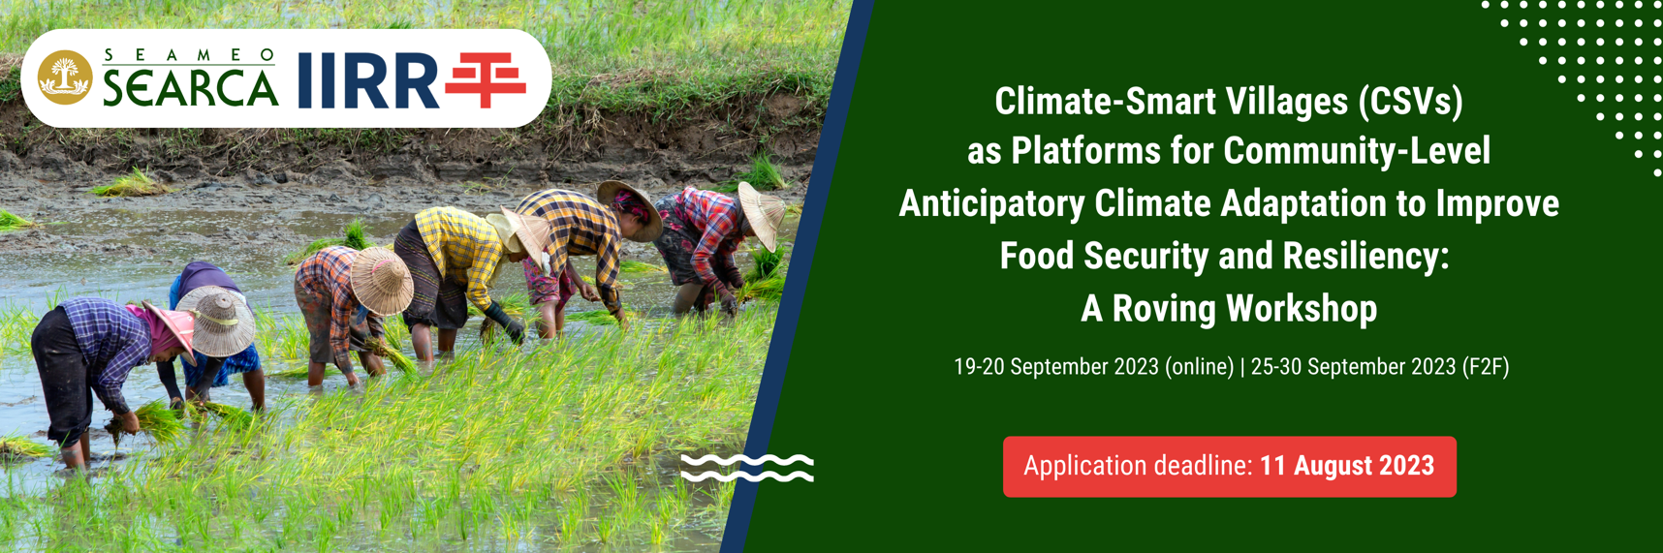

APPLICATION FORM
Privacy Statement and Consent to Use Data

SEAMEO SEARCA and IIRR respect your privacy, and we are committed to treat your personal data with utmost fairness, responsibility, and security. Thus, personal information that you share with us are treated with uttermost care, integrity, and sensitivity. All personal details and photo/video/audio documentation related to your participation in this roving workshop are managed by the two institutions for educational purposes. Such are gathered for use in reports, documents, publications, and audio-video productions; for inclusion in databases of participants, partners, and stakeholders; and to send evaluation instruments and other post-training-workshop documents as needed; and will not be transferred to any organization that does not have adequate data protection policies. SEARCA and IIRR will keep your personal data not longer than six years after the fulfilment of the purposes set out in this notice and in accordance with the Center’s data privacy guidelines.

By accomplishing and submitting this Application Form, you signify that you give consent to the collection and use of your personal information, as well as photo/video/audio documentation, for purposes stated above.
PERSONAL INFORMATION
First Name: | Middle Name: |  | Last Name:
Gender: | Date of Birth (mm/dd/yyyy): | Nationality/Citizenship: |  | Civil Status:
Religion:

Permanent Mailing Address:

Home Phone: | Email Address/es:
Mobile No: |  | Dietary Restrictions/Food Allergies, if any:

Select your application category
Applying for a SEARCA grant (subsidized course fee)
Sponsored by my company/organization
Self-paying participant

If you are applying for a SEARCA grant, below are the criteria for selection:
- Relevance of present position/role in relation to the course objectives;
- Proficiency in spoken and written English (all sessions will be conducted in English);
- With regular full-time appointment on active status (not on leave) or with a long-term contract as consultant/job order, as certified by the Head of Human Resource and Development of the sending institution/organization, and likely to serve the institution/organization for at least two more years;
- Clearly expressed willingness to participate actively in the full learning event, including support from the direct supervisor;
- Endorsed by the organization/institution head; and
- Has prepared a draft Re-Entry Action Plan (REAP).

EMPLOYMENT
Position Title: |  | No. of years total professional working experience:
Office/Organization: |  | No. of years at present position:
Office Address: |  | No. of years with present organization:
Office Telephone:
Office Fax:
Name of Manager/Superior and Email Address/es:

Previous Positions | Organization |  | Inclusive Dates (ex.: 2000-2003)

EDUCATION
Degree (obtained) (please indicate fields/areas of specialization) | Institution/University | Location | Award Date

LANGUAGE PROFICIENCY
(Required for international applicants; please check appropriate response)
English Language Skills | Poor | Average | Good | Excellent
Reading
Speaking
Writing
Listening

PASSPORT DETAILS
(Required for international applicants; your passport should have at least six months validity at the time of your arrival in Manila, Philippines)
Exact Name on Passport:
Passport Number:
Date and Place of Issue:
Expiration Date:

Professional Awards

Please list any work-related distinctions, including positions on advisory boards, government or international commissions, professional associations, etc.

PERSONAL STATEMENTS
As part of your application, please answer the following questions in less than 250 words per question. If you are applying for a SEARCA grant, please respond to questions #1 and #2. If you are a self-paying participant or sponsored by your organization or any funding agency, please respond only to question #1.

- Describe your current work responsibilities. For what kinds of activities, operations, and decisions are you directly responsible?

- Please describe below the main reasons why you should be awarded the SEARCA grant to participate in this roving workshop and how your attendance at the course could help you, your colleagues, and your organization.

Certified true and correct by:

Applicant’s Signature: _____________________________________

Printed Name: _____________________________________

Date: _____________________________________

Endorsed by:

Agency Official Seal
Signature of Head of Agency: _______________________________

Printed Name: _______________________________

Position: _______________________________

Date: _______________________________

SUBMITTING THE APPLICATION

All the following documents* must be received by 11 August 2023 through the application portal:
http://bit.ly/CSVCCA2023

- Fully accomplished and signed APPLICATION FORM in PDF format, with the signature clearly visible. A scanned signature is acceptable.

- Applicant’s CURRICULUM VITAÉ;

- The signed and in PDF formats of NOMINATION FORM, STATEMENT OF COMMITMENT, AND RE-ENTRY ACTION PLAN; and

- Scanned bio page of the applicant’s VALID PASSPORT.

*Label your documents with your surname and name of the form before uploading in PDF format.

