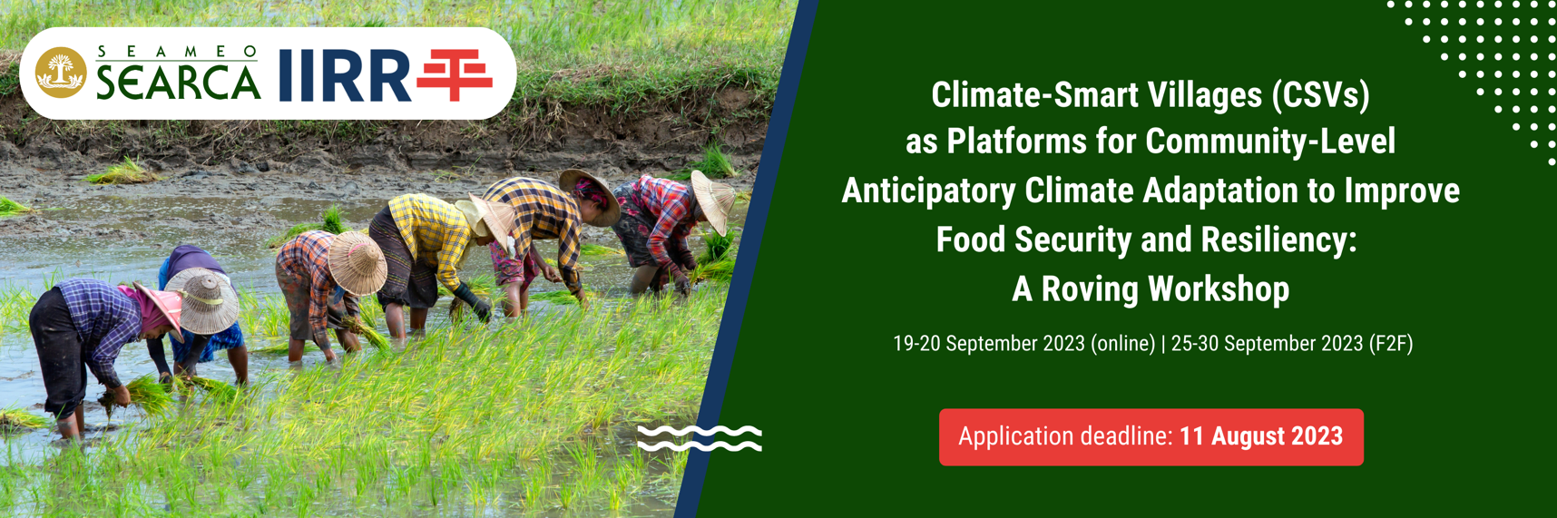

NOMINATION FORM
Privacy Statement and Consent to Use Data

SEAMEO SEARCA and IIRR respect your privacy, and we are committed to treat your personal data with utmost fairness, responsibility, and security. Thus, personal information that you share with us are treated with uttermost care, integrity, and sensitivity. All personal details and photo/video/audio documentation related to your participation in this roving workshop are managed by the two institutions for educational purposes. Such are gathered for use in reports, documents, publications, and audio-video productions; for inclusion in databases of participants, partners, and stakeholders; and to send evaluation instruments and other post-training-workshop documents as needed; and will not be transferred to any organization that does not have adequate data protection policies. SEARCA and IIRR will keep your personal data not longer than six years after the fulfilment of the purposes set out in this notice and in accordance with the Center’s data privacy guidelines.

By accomplishing and submitting this Nomination Form, you signify that you give consent to the collection and use of your personal information, as well as photo/video/audio documentation, for purposes stated above.

Nominating Office:

Address of Office:

Telephone Number:

Office E-mail Address/es:

Please state briefly the nominee’s involvement in your organization:
How will the workshop benefit the nominee, your organization, and your organization’s stakeholders (please answer briefly but concisely):

The undersigned, acting on behalf of _________________________________________ hereby
(Nominating Office)

certifies/confirms the nomination of _________________________________________________
(Name of Nominee)

for the “Climate-Smart Villages (CSVs) as Platforms for Community-Level Anticipatory Climate Adaptation to Improve Food Security and Resiliency: A Roving Workshop” of SEARCA and IIRR. The nominee will attend both the online (19-20 September 2023) and face-to-face (25-30 September 2023) sessions. He/She is a member of our staff working on program/projects/activities to promote agricultural and rural development (ARD), is not of retireable age, has a good command of the English language, is physically fit to travel, and actively participate in the said workshop, and will return to our organization to resume work with us after the event.

Name of Head of Office/Organization:

Designation:

Signature:

Address:

Official stamp/seal of office:

IMPORTANT NOTE: This nomination form must be submitted, together with the accomplished application form and other pertinent documents by 11 August 2023 through the application portal: http://bit.ly/CSVCCA2023

