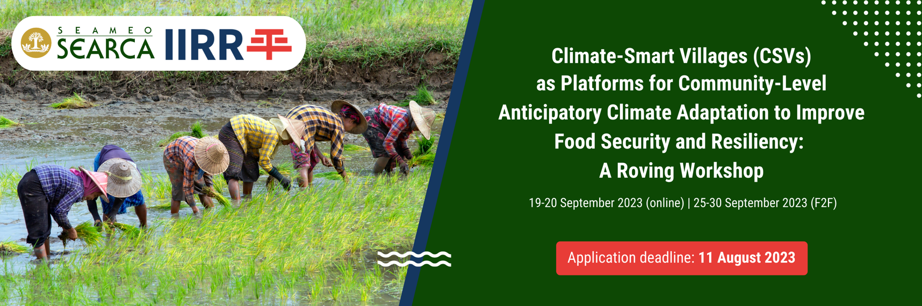

RE-ENTRY ACTION PLAN
BRIEFER & TEMPLATE

Below is a quick guideline for preparing a Re-entry Action Plan (REAP), along with the recommended template. Please note that submission of your REAP is part of your application requirements for the CSVCA Roving Workshop.

What is a REAP?

The Re-Entry Action Plan (REAP) is a mechanism that enables participants to apply what they learned, implement better work processes, and improve their organization’s efficiency and effectiveness.

It sketches a change initiative in which participants utilize new or enhanced competencies to address a real problem or opportunity in the workplace.

It will allow SEARCA and IIRR to follow up on the performance of the participants after completing the roving workshop.

Why make a REAP?

The REAP addresses the challenge of translating learning into tangible improvements in an organization/program/project.

It bridges not only the gap between the classroom and the workplace but more importantly, it links the acquisition and use of competencies at the individual level to the achievement of organizational outcomes.

Objectives of the REAP

- To identify what you want to achieve in your re-entry into your office/workplace that would entail the application of new/enhanced learning gained from the training; and

- To determine processes and/or practices that will be changed (enhanced, improved, added, or removed) in your project/workplace due to the implementation of the REAP.

It is highly preferred that your REAP is beneficial to your project/program, your unit, or to the end clients/stakeholders.
*RE-ENTRY ACTION PLAN TEMPLATE

Name of your organization
Your name
Designation and Dept/Office

- Enumerate at least three (3) problems or opportunities in your organization where learnings from the workshop can be applied.

- Enumerate at least three (3) learnings from the workshop which can help solve the problems or enhance the opportunities mentioned above.

- Enumerate the action steps on how your learnings can be implemented in your re-entry to your organization, including timeline and resources.

- What are the potential barriers* that you might encounter in your REAP?

- What benefits and outcomes are you eyeing for in the implementation of your REAP?

*May also include barriers in terms of available technologies, organizational policies (both internal and external, impact of pandemic, etc.

Evidence of Success
(How will you know that you are making progress? What are your benchmarks?)

Evaluation Process
(How will you determine that your goal/s has/have been reached? What are your measures?)

*This is your initial REAP, which you will refine/revise during the onsite session based on your actual learnings and emerging insights from your overall experience in the roving workshop.

